**Investment Summary: Spring Airlines Co Ltd (601021.SS)**

As of: 5 September 2025  
Stock Price (previous close): 53.35 CNY  
Market Cap: Approx. 50.5 billion CNY  
Industry: Airline (Low-Cost Carrier)  
Recommended Action: Hold

**Business Overview**

Spring Airlines Co Ltd operates as a low-cost airline in China, providing air passenger and cargo transportation across over 100 domestic and international destinations. The company’s business model focuses on competitive pricing, operational efficiency using a modern fleet (predominantly Airbus A320), and expanding market share in the Asia-Pacific aviation sector. Its revenue for FY 2024 was approximately RMB 20 billion (~$3 billion), with an operating margin around 12.9%. The airline caters mainly to price-sensitive leisure and business travelers seeking cost-efficient travel options. Strengths include a lean cost structure and strategic partnerships with tourism boards; challenges involve rising fuel costs, regulatory compliance costs, and fierce industry competition.

**Business Performance**

* Revenue grew from RMB 17.9 billion in 2023 to RMB 20 billion in 2024 (approx. 11.5% growth).
* Net income for 2024 estimated at RMB 2.27 billion, up slightly from 2023.
* Operating cash flow improved to about RMB 5.9 billion in 2024, supporting ongoing expansion.
* Market share in domestic Chinese low-cost air travel is roughly 7%, with a strong competitive position among peers such as China United Airlines and Juneyao Airlines.

**Industry Context**

* The airline industry is moderately mature with steady recovery post-pandemic.
* China's domestic airline market shows a CAGR of about 8-10% driven by increased domestic and international travel demand.
* Spring Airlines ranks among the top low-cost carriers in China, though competition remains intense.
* Sales and EPS growth slightly outpace industry averages due to aggressive pricing and route expansion strategies.
* Debt-to-total assets ratio near industry norms, leverage manageable.

**Financial Stability and Debt Levels**

Spring Airlines maintains a stable liquidity position with a current ratio slightly above 1.3, adequate cash on hand, and strong operating cash flows of RMB 5.9 billion (2024). Debt-to-equity ratio stands around 1.29, suggesting moderate leverage typical for the capital-intensive airline sector. Interest coverage ratios and Altman Z scores indicate prudent financial management with low bankruptcy risk.

**Key Financials and Valuation**

* FY 2024 Revenues: RMB 20 billion, YoY growth ~11.5%.
* Net Income (2024): ~RMB 2.27 billion, margin expansion visible post-pandemic.
* P/E ratio (TTM) around 15x, slightly below sector average, with dividend yield approx. 2.4%.
* Stock trades somewhat above DCF valuation (fair value estimate ~35.91 CNY vs. 53.35 current price), signaling potential overvaluation with downside risk of -32.7% per DCF models.
* Industry specific metrics include a load factor of ~78%, slightly below the industry average of 82%, indicating room for improvement in capacity utilization.

**Big Trends and Events**

* Rising fuel and operational costs pressure margins.
* Regulatory tightening on safety and environmental standards increase compliance costs.
* Post-pandemic travel recovery boosts demand and route expansions, favoring low-cost options like Spring Airlines.
* Digital transformation and strategic partnerships strengthen competitive differentiation.

**Customer Segments and Demand Trends**

* Major customer base: Leisure travelers (60%+), business travelers (30%), cargo transport (10%).
* Forecast: 8-10% revenue CAGR over next 3 years driven by domestic recovery and expanding international routes.
* Pricing remains competitive, but customer switching costs low due to availability of alternative carriers.

**Competitive Landscape**

* Highly competitive industry with CR4 (top 4 carriers) controlling majority market share.
* Main competitors: China United Airlines, Juneyao Airlines.
* Spring Airlines’ moat: Low-cost structure, efficient fleet, brand recognition in domestic low-cost segment.
* Key battle front: Scale and operational efficiency; Spring's fleet size and route network compare favorably vs competitors.

**Risks and Anomalies**

* Exposure to fuel price volatility impacting margins.
* Regulatory risks related to safety and environmental policies.
* Operational disruptions and relatively lower punctuality compared to peers (78% vs. 82%).
* Debt levels moderate but require monitoring.

**Forecast and Outlook**

* Management projects continued revenue growth at 8-10% CAGR with improving profitability.
* New international routes to drive incremental revenue.
* Earnings per share expected to rise to RMB 4.5 by 2025.

**Leading Investment Firms and Views**

* Consensus analyst rating aligns with Hold; top firms highlight strong growth but caution on valuation risk.
* Average target price range around 35-40 CNY, indicating potential downside.
* Dividend yield supports income investors moderately.

**Recommended Action: Hold**

Pros:

* Strong revenue and earnings growth post-pandemic recovery.
* Cost leadership and expanding route network support competitive positioning.
* Stable financials with manageable leverage.

Cons:

* Stock currently trades above fair value estimates per DCF, implying downside risk.
* Exposure to high fuel costs and regulatory changes add margin pressure.
* Intense competition and operational risks persist.

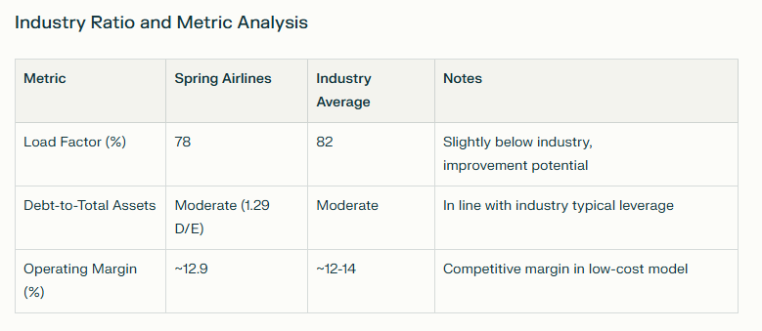

**Key Takeaways**

Spring Airlines is a well-positioned low-cost Chinese airline benefiting from strong demand recovery and strategic expansions, supported by efficient operations. While it faces risks from cost pressures and valuation concerns, steady cash flow and a dominant market niche warrant a Hold recommendation with potential for gains if cost controls improve. Monitoring fuel cost trends and regulatory impacts is advisable for investors.

**Sources**

* [Spring Airlines Financials and Forecast - dcfmodeling.com](https://dcfmodeling.com/blogs/health/601021ss-financial-health)
* [DCF Valuation Summary - ValueInvesting.io](https://valueinvesting.io/601021.SS/valuation/dcf-growth-exit-5y)
* [Yahoo Finance - Spring Airlines](https://finance.yahoo.com/quote/601021.SS/)
* [Investing.com - Financial Summary](https://www.investing.com/equities/spring-airlines-co-ltd-financial-summary)
* [Reuters Company Profile](https://www.reuters.com/markets/companies/601021.SS/)